Reg.No.Maharastra 6680/2000 Dt. 18/8/2000 NASHIK GRAMI N SHIKSHAN PRASARAK MANDAL`S
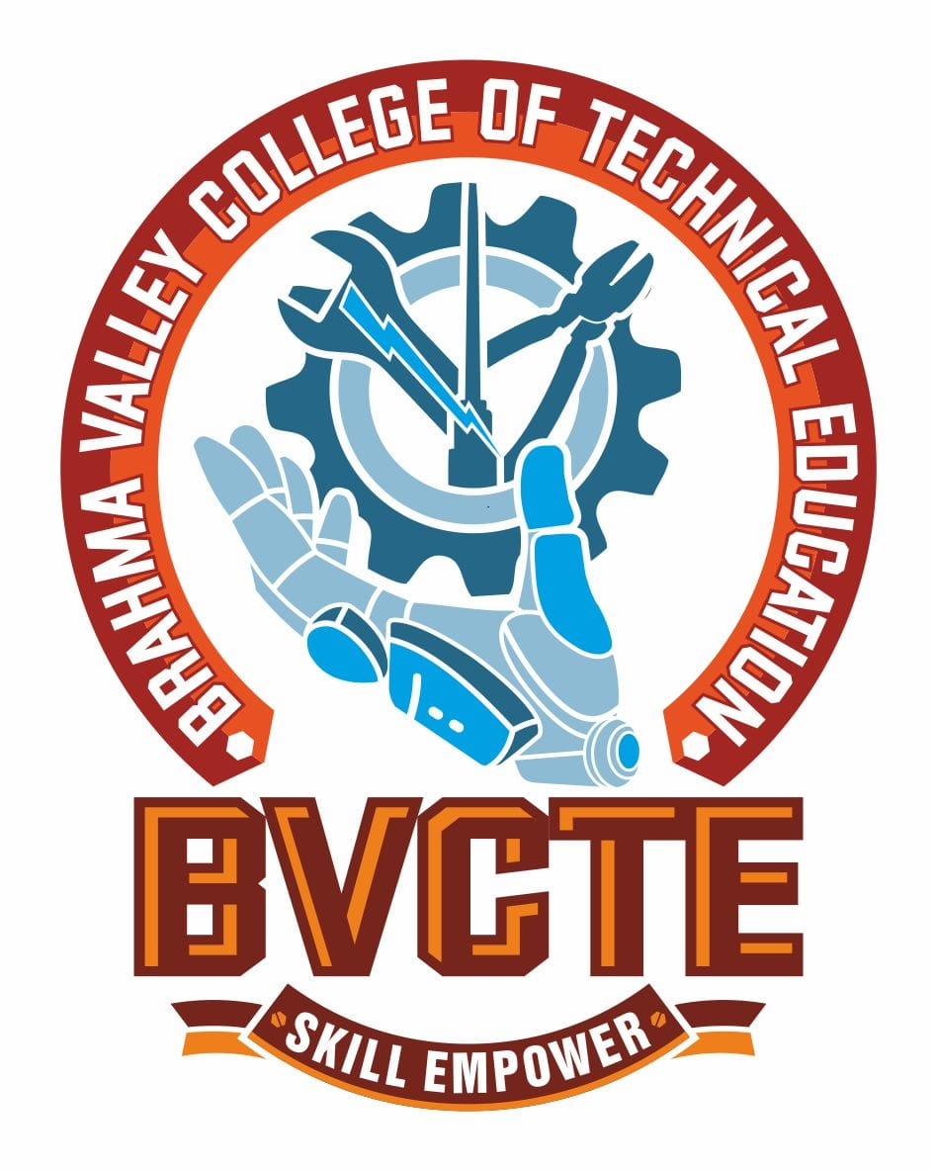
Reg.No.F/6586 (Nashik) Dt: 8/2/2001 BRAHMA VALLEY COLLEGE OF
TECHNICAL EDUCATION
(POLYTECHNIC)
Approved by: AICTE, New Delhi Anjaneri, Trimbak Road, Dist. Nashik-422213
Directorate of Technical Education. Mumbai Tel. (02594) 220200,220152, 220153
Affiliated to: M.S.B.T.E, Mumbai Email: principalbvp@rediffmail.com
www.brahmavalley.in

DEPARTMENT
OF
ELECTRICAL ENGINEERING

PROGRAMME OUTCOMES (PO):

(What she/he will be able to do at the entry point of industry soon after diploma programme)

- PO1: Basic and Discipline specific knowledge: Apply knowledge of basic mathematics, science and engineering fundamentals and engineering specialization to solve the engineering problems.
- PO2: Problem analysis: Identify and analyse well-defined engineering problems using codified standard methods.
- PO3: Design/ development of solutions: Design solutions for well-defined technical problems and assist with the design of systems components or processes to meet specified needs.
- PO4: Engineering Tools, Experimentation and Testing: Apply modern engineering tools and appropriate technique to conduct standard tests and measurements.
- PO5: Engineering practices for society, sustainability and environment: Apply appropriate technology in context of society, sustainability, environment and ethical practices.
- PO6: Project Management: Use engineering management principles individually, as a team member or a leader to manage projects and effectively communicate about well-defined engineering activities.

- PO7: Life-long learning: Ability to analyse individual needs and engage in updating in the context of technological changes.

Reg.No.Maharastra 6680/2000 Dt. 18/8/2000 NASHIK GRAMI N SHIKSHAN PRASARAK MANDAL`S
Reg.No.F/6586 (Nashik) Dt: 8/2/2001 BRAHMA VALLEY COLLEGE OF
TECHNICAL EDUCATION
(POLYTECHNIC)
Approved by: AICTE, New Delhi Anjaneri, Trimbak Road, Dist. Nashik-422213
Directorate of Technical Education. Mumbai Tel. (02594) 220200,220152, 220153
Affiliated to: M.S.B.T.E, Mumbai Email: principalbvp@rediffmail.com
www.brahmavalley.in

DEPARTMENT
OF
ELECTRICAL ENGINEERING

Programme Educational Objectives (PEO):

(What she/he will continue to do even after 3-5 years of working in the industry)

- PEO1: Provide socially responsible, environment friendly solutions to Computer engineering related broad-based problems adapting professional ethics.

- PEO2: Adapt state-of-the-art Computer engineering broad-based technologies to work in multi-disciplinary work environments.

- PEO3: Solve broad-based problems individually and as a team member communicating effectively in the world of work.

Program Specific Outcomes
(PSO):

Program Specific Outcomes (PSOs):

(What she/he will be able to do in the Electrical Engineering industry soon after the diploma programme)
PSO1: Electrical Systems Operation and Maintenance
Apply modern electrical tools, techniques, and practices for the operation, maintenance, and troubleshooting of electrical machines, power systems, and related equipment.
PSO2: Electrical Software and Hardware Utilization
Use state-of-the-art technologies for application and management of electrical engineering-related software and hardware systems such as simulation tools, circuit design software, and control systems.

