Reg.No.Maharastra 6680/2000 Dt. 18/8/2000 NASHIK GRAMI N SHIKSHAN PRASARAK MANDAL`S
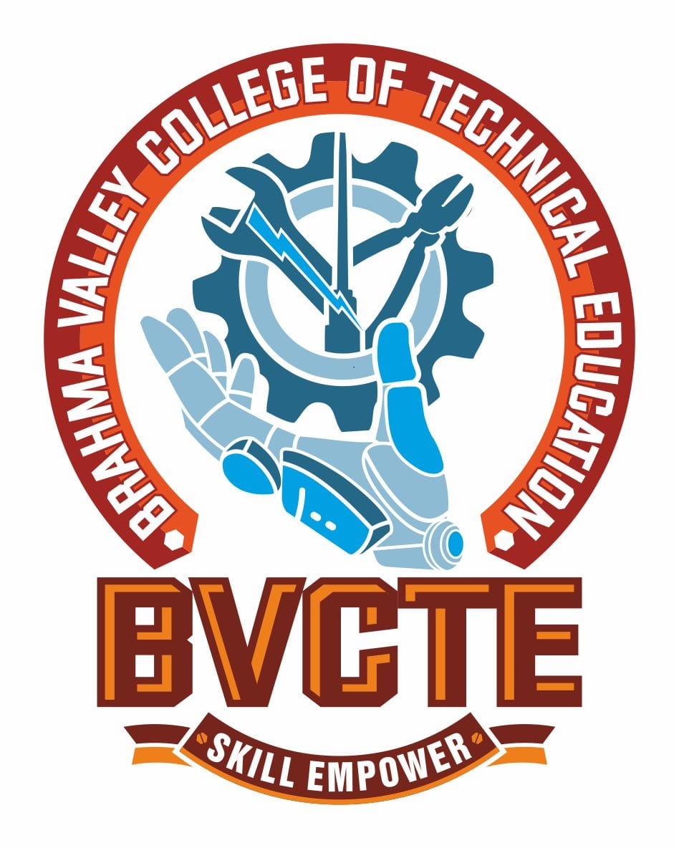
Reg.No.F/6586 (Nashik) Dt: 8/2/2001 BRAHMA VALLEY COLLEGE OF
TECHNICAL EDUCATION
(POLYTECHNIC)
Approved by: AICTE, New Delhi Anjaneri, Trimbak Road, Dist. Nashik-422213
Directorate of Technical Education. Mumbai Tel. (02594) 220200,220152, 220153
Affiliated to: M.S.B.T.E, Mumbai Email: principalbvp@rediffmail.com
www.brahmavalley.in

DEPARTMENT
OF
ELECTRONICS & COMPUTER ENGINEERING

PROGRAMME OUTCOMES (PO):
(What she/he will be able to do at the entry point of the industry soon after the diploma programme)
PO1: Basic and Discipline Specific Knowledge
Apply knowledge of basic mathematics, science, and engineering fundamentals along with domain-specific knowledge to solve broadly-defined engineering problems.
PO2: Problem Analysis
Identify and analyze well-defined engineering problems using standard methods and practices relevant to electronics and computer engineering.
PO3: Design / Development of Solutions
Design practical solutions for defined technical problems and assist in the development of electronic circuits, embedded systems, and computer-based applications.
PO4: Engineering Tools, Experimentation, and Testing
Apply modern tools and techniques to conduct tests, analyze results, and support system improvements in electronics and computing.
PO5: Engineering Practices for Society, Sustainability, and Environment
Demonstrate awareness of social responsibilities, sustainable development, and ethical practices while applying engineering solutions.
🔹 PO6: Project Management
Use basic engineering management principles as an individual or in a team to execute projects and communicate effectively in technical settings.
🔹 PO7: Life-long Learning
Recognize the need for continuous learning and technological adaptation in the fast-changing electronics and IT industry.

Reg.No.Maharastra 6680/2000 Dt. 18/8/2000 NASHIK GRAMI N SHIKSHAN PRASARAK MANDAL`S
Reg.No.F/6586 (Nashik) Dt: 8/2/2001 BRAHMA VALLEY COLLEGE OF
TECHNICAL EDUCATION
(POLYTECHNIC)
Approved by: AICTE, New Delhi Anjaneri, Trimbak Road, Dist. Nashik-422213
Directorate of Technical Education. Mumbai Tel. (02594) 220200,220152, 220153
Affiliated to: M.S.B.T.E, Mumbai Email: principalbvp@rediffmail.com
www.brahmavalley.in

DEPARTMENT
OF
ELECTRICAL ENGINEERING

Programme Educational Objectives (PEO):
(What she/he will continue to do even after 3–5 years of working in the industry)
PEO1: Deliver efficient and responsible electronic and computer engineering solutions that align with environmental and ethical standards.
PEO2: Adapt to evolving technologies in embedded systems, networking, automation, and computing for interdisciplinary roles.
PEO3: Effectively contribute as an individual or team member in solving industry-relevant problems and communicating in a professional environment.

Program Specific Outcomes
(PSO):

Program Specific Outcomes (PSOs):
(What she/he will be able to do in the Electronics and Computer Engineering industry soon after the diploma programme)
PSO1: Embedded and Electronic System Design
Apply knowledge and tools to design, develop, and troubleshoot embedded systems, electronic circuits, and control systems used in automation and communication fields.
PSO2: Computer and Networking Applications
Use software, programming languages, and network technologies to develop and manage computer-based systems, IoT applications, and digital electronics projects.

